Node.js Basics
Basics JS code:-
const greet = (name) =>{
console.log(`Hello, ${name}`)
}
greet("ram")
PS C:\Users\kumar\OneDrive\Desktop\Resume\NodeJS\02_Node.js Basics> node test
Hello, ram

The global object is an object that provides variables, functions, and properties that are available globally in a JavaScript environment. JavaScript provides them automatically, so you don't need to create them yourself.
The global object depends on where JavaScript runs:
- Browser → window
- Node.js → global
- Modern standard → globalThis (works across environments)
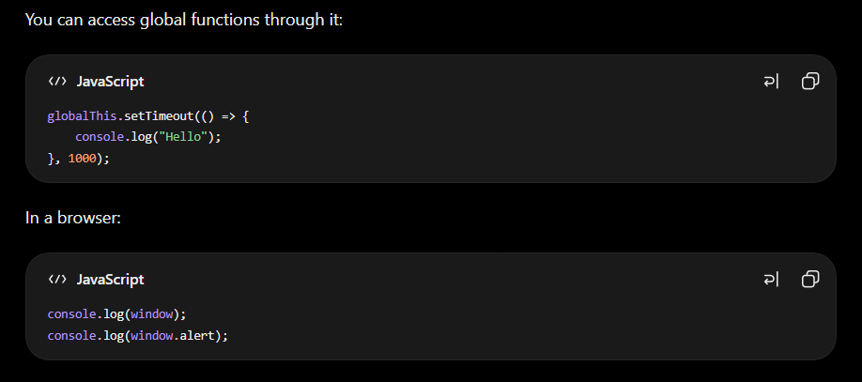
When we run console.log(global) in Node.js, it displays the global object, which contains globally accessible properties, functions, and objects provided by the Node.js runtime.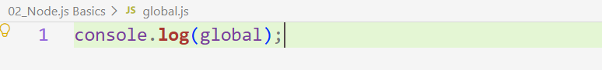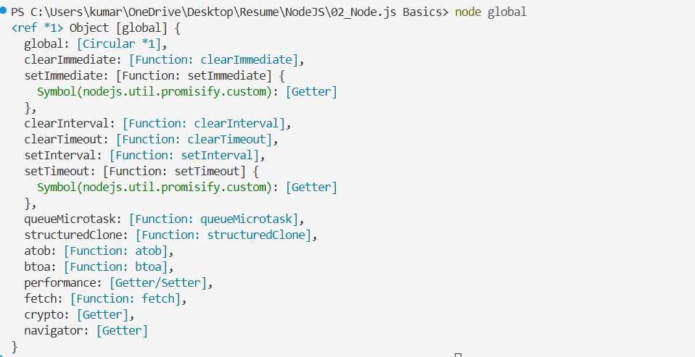
Example 1:- setInterval() repeatedly executes a function at a specified time interval. For example, it can print a sentence every 4 seconds. It behaves somewhat like a loop, but instead of continuously looping, it waits for the specified interval between executions. 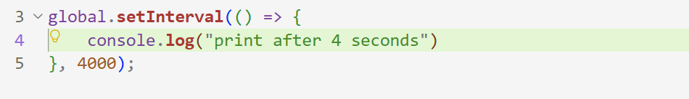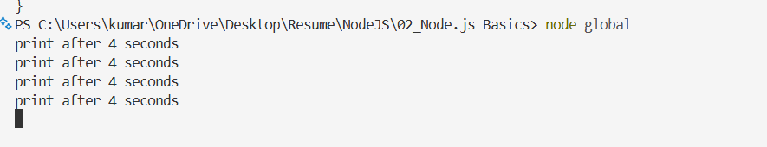

Example 2 :- We don't need to write the full global.setTimeout() or global.setInterval() syntax. Since these functions are available globally in Node.js, we can directly use setTimeout() and setInterval().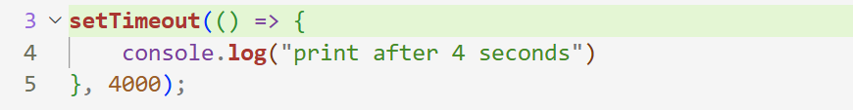

Example 3:- Here, setTimeout() schedules a function to run after 4 seconds, but JavaScript does not wait for those 4 seconds. It continues executing the rest of the code immediately. Meanwhile, the setInterval() callback can run every 3 seconds. After 4 seconds, the setTimeout() callback executes. Inside that callback, clearInterval() can be used to stop the repeated execution of the interval.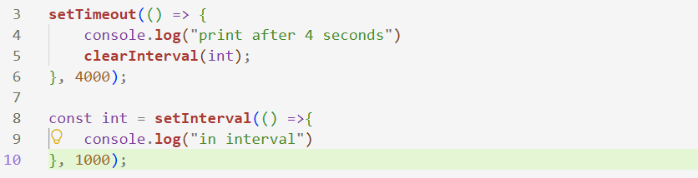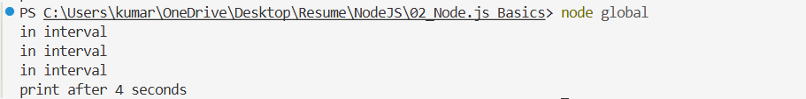
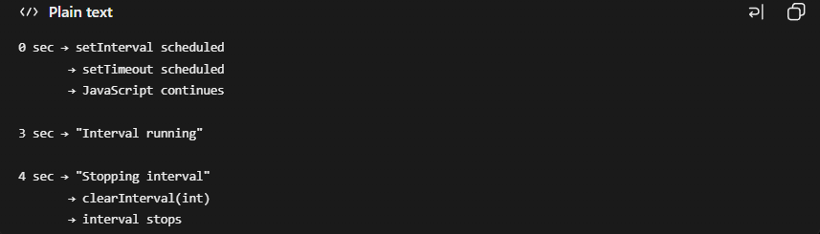

Example 4:- The first one gives the directory (folder path) of the current code file, while the second gives the exact path/location of the current file itself.

window and global are different global objects provided by different JavaScript environments. window is associated with the browser, while global is associated with Node.js. Since Node.js runs JavaScript outside the browser, typically on the server/backend, it provides its own environment-specific APIs such as global, process, __dirname, and __filename.
Example 5:- There are in two different files as we can see.
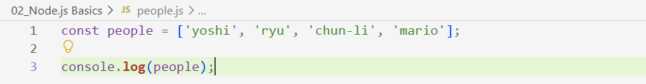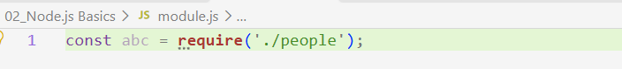
When we use require() to import a Node.js module, Node.js executes the module's code when it is loaded. Therefore, any console.log() statements or other executable code inside people.js will run, and if people.js exports an array, require() returns that exported array.
In this case, const abc does not receive any value because the people.js file does not export anything; it only executes console.log(). The require() statement is what loads and executes the module, but the value assigned to abc comes specifically from module.exports.

Example 6:- If we want to access the data or functionality from people.js inside another file such as module.js, we need to explicitly export it from people.js using module.exports. The require() statement in module.js only loads the module and retrieves whatever people.js has exported.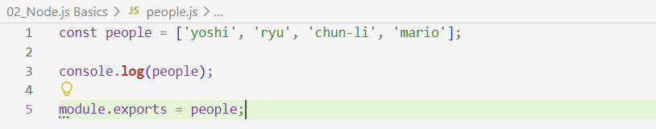 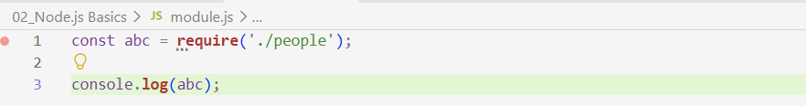

If we want to export multiple variables from a module, we can export them as properties of an object:
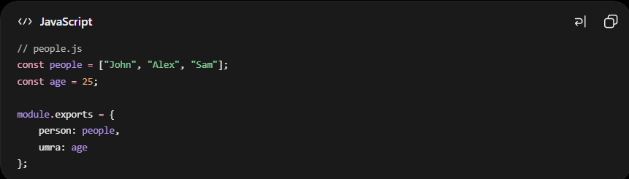
Here, person and umra are the property names, so they don't have to match the variable names people and age.

If the property name and variable name are the same, JavaScript provides property shorthand: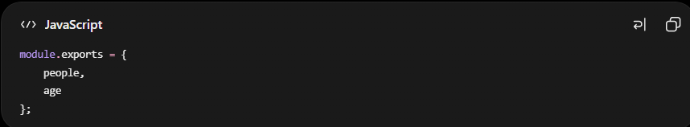
This is equivalent to: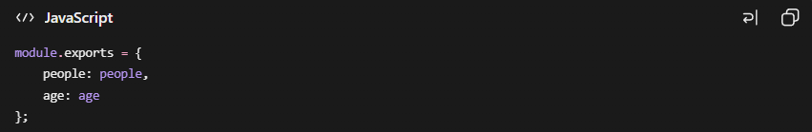
Example 7:-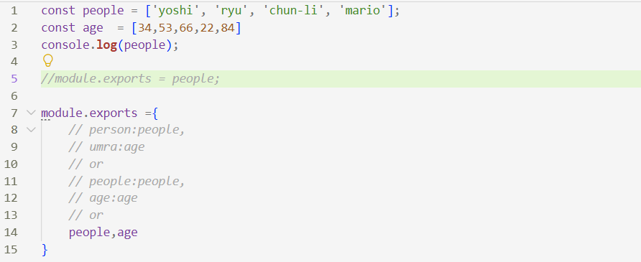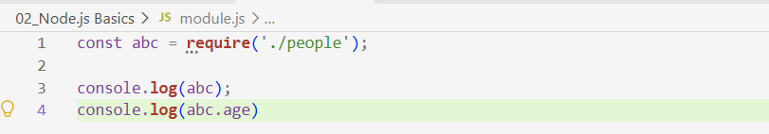

abc itself is an object because require() returns the object exported from people.js. When we access abc.age, we are accessing the age property of that object. If the value stored in age is an array, then abc.age returns that array.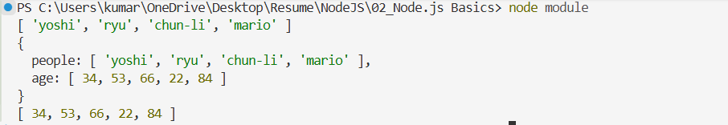

Example 8:- If we only want to access one property, such as people or age, in module.js, we can use destructuring while importing the module.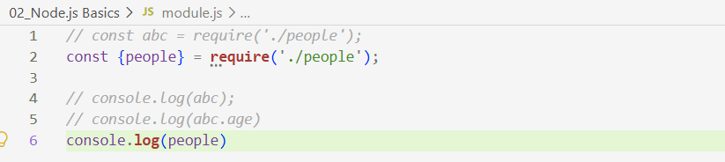
The people.js file does not need to be changed. The only condition is that the property name used in module.js must match the corresponding property exported from people.js. We can also use const { people, age } to access both properties at the same time.

Example 9:- There are many built-in modules provided by Node.js that we can import and use. One important example is the OS module, which provides information and utilities related to the operating system.
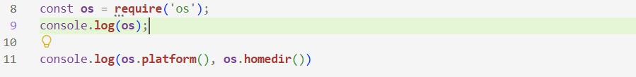

The OS module provides many built-in methods, such as arch(), freemem(), and many others, which allow us to retrieve information about the operating system and system resources.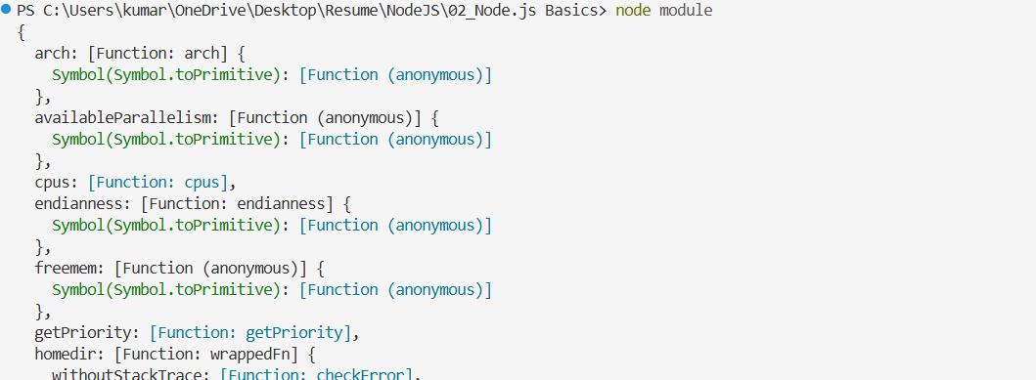 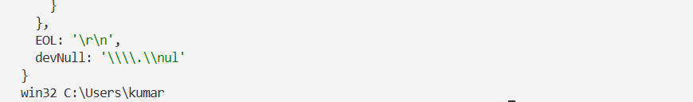
We can use the OS module to get information about the system and the home directory.

Another important built-in Node.js module is the File System module (fs), which provides methods for working with files and directories.

Example 10:- We are using the File System (fs) module here. The err parameter captures any error that occurs while reading the file, such as an incorrect file name or a file that does not exist. The data returned by readFile() is a Buffer object by default, so we convert it to a string to read the actual file content.
readFile() is an asynchronous operation, so JavaScript does not wait for the file-reading operation to finish. If there is other code that can execute immediately, it can run while the file is being read. The function passed to readFile() is a callback function, which executes after the file-reading operation completes and the contents of blog1.txt are available.
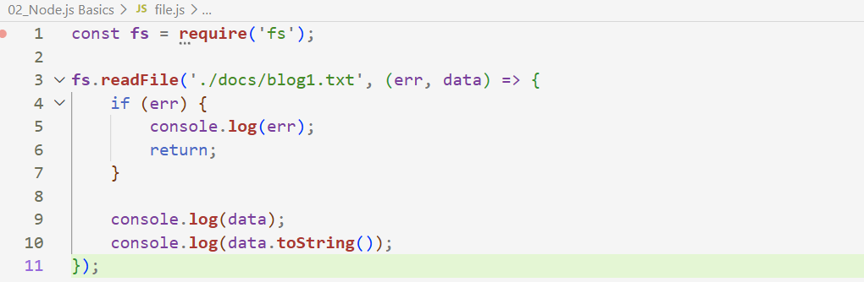
The blog1.txt file contains the text "hello, ninjas". When readFile() successfully reads the file, this text is returned in the data parameter as a Buffer, which can then be converted into a string. The general syntax for readFile() is:
fs.readFile(filePath, (err, data) => {
// handle error or process data
});

Example 11:- As we can see, the console.log() statement written after readFile() executes first because readFile() is asynchronous. JavaScript starts the file-reading operation and continues executing the next lines without waiting for the file to be read. Once the file-reading operation is complete, the callback function executes.
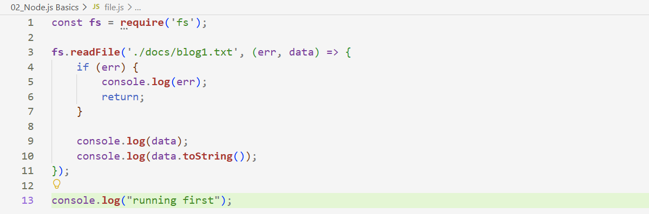
Example 12:- We can also write data to a file using writeFile(). It writes the provided content to the specified file and then executes the callback function once the operation is complete. If the file does not already exist, writeFile() creates it automatically instead of producing an error. If the file already exists, its existing content is overwritten by default.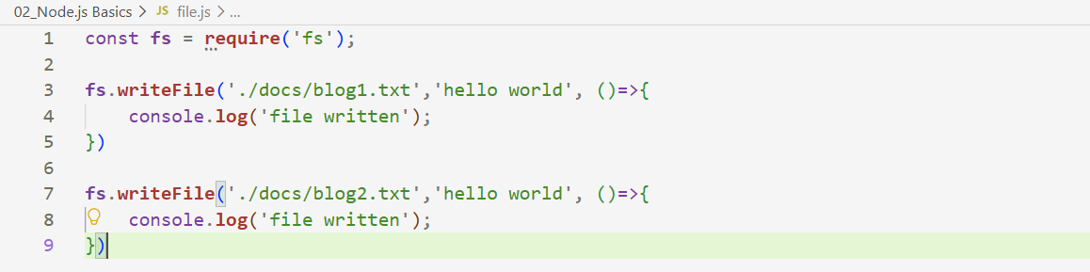
The general syntax of writeFile() is:
fs.writeFile(filePath, data, (err) => {
// handle error or process completion
});
Example 13:- We can also create and delete directories using the File System (fs) module. Before using the if condition, we need to understand a possible error with mkdir(): it produces an error if we try to create a directory that already exists.
Therefore, we first use fs.existsSync() to check whether the directory exists. Since we want to create the directory only when it does not exist, we use the ! operator to reverse the result. If existsSync() returns false, !false becomes true, so the if block runs and creates the directory. If it returns true, !true becomes false, so the if block is skipped. The else block then deletes the existing directory.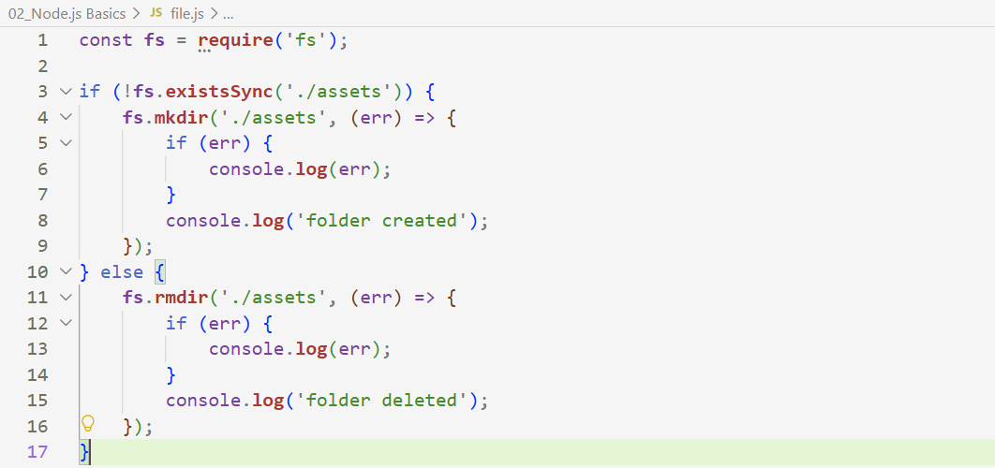
The assets directory did not exist initially, so the first time we ran the code, it was created. When we ran the code a second time, the directory already existed, so the else block executed and deleted it. When we ran the code a third time, the directory no longer existed, so the if block executed and created it again.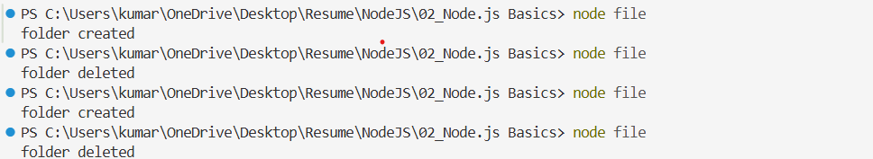
The syntax for creating and deleting directories using the fs module is:
fs.mkdir(path, callback);
fs.rmdir(path, callback);
Example 14:- We check whether deleteme.txt exists using fs.existsSync(). If it exists, we use the unlink() method to delete the file.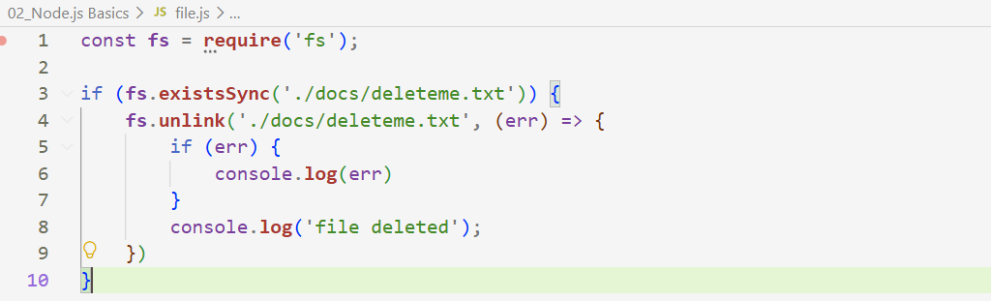
If we run the code again, nothing happens because the file has already been deleted, so fs.existsSync() returns false and the if condition does not execute. Without this existence check, calling unlink() on a file that does not exist would produce an error.
Stream and Buffer :- The methods we discussed work well for small files, but for large files or continuous data, Node.js provides streams and buffers. Instead of loading the entire file into memory at once, a stream processes the data incrementally in small chunks.
These chunks are represented as Buffer objects for binary data. Since processing can begin as soon as the first chunk arrives, we don't have to wait for the entire file to load, which reduces memory usage and improves responsiveness.
There are two commonly used types of streams: Readable Streams and Writable Streams. A readable stream is used to read data chunk by chunk, while a writable stream is used to write data chunk by chunk.

Example 15:- We use createReadStream() to specify which file we want to read. We then use the .on() event listener to listen for incoming data. Whenever a chunk of data is available, the callback receives that chunk, allowing us to process it immediately instead of waiting for the entire file to be read.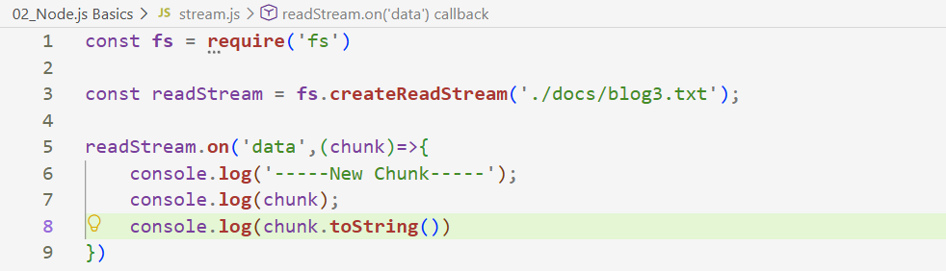
Alternatively, we can specify an encoding when creating the read stream. This makes the stream return the data as a string instead of a Buffer, so we don't need to use chunk.toString() manually.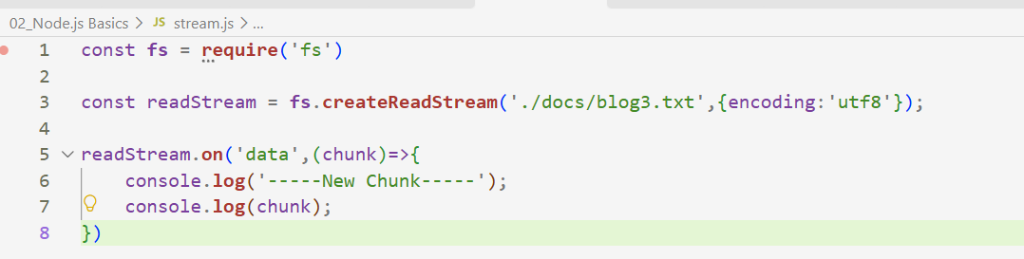
We receive the data in multiple chunks, one after another, as the stream reads the file. Each chunk contains only a portion of the overall data, allowing us to process it incrementally instead of waiting for the entire file to be loaded.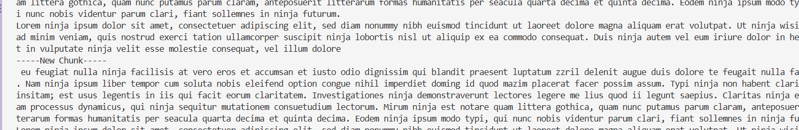
Here, we use .write() to write data to the file connected to the stream. We create the writable stream using createWriteStream(), which also creates the file if it does not already exist. We can then write data chunk by chunk, allowing us to handle large amounts of data incrementally.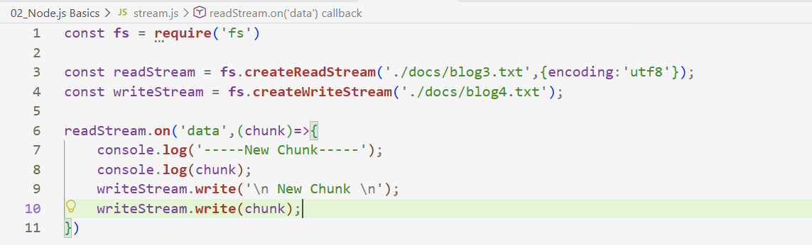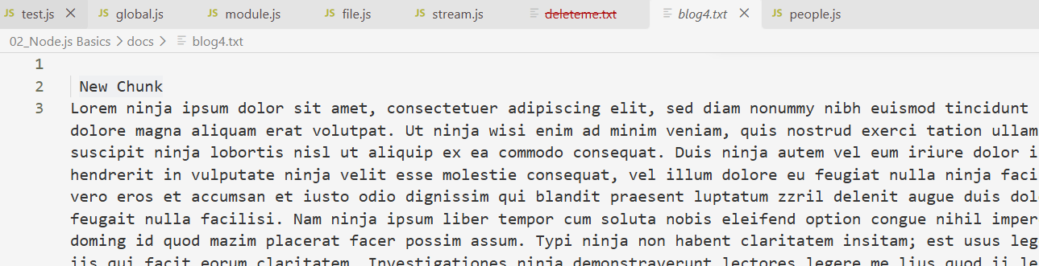
Piping :- Piping is a simpler way to transfer data from a Readable Stream to a Writable Stream. Instead of manually listening for chunks and writing each chunk using .write(), we can use .pipe() to automatically pass the data from the readable stream to the writable stream. It is particularly useful for handling large amounts of data efficiently.
Example 16:- We use .pipe() here to connect the readable stream directly to the writable stream. The only change from our previous approach is that we no longer manually add the extra "New Chunk" text or handle each chunk ourselves. The rest of the setup remains the same.

